|  |
| --- |
|  |
| Genet and Ramet Survivorship Simulator |
| SYSC 5104: Methodologies for Discrete-Event Modeling and Simulation |
|  |
| **Ahmad Moughnie 100846441** |
| **03-Nov-16** |

|  |
| --- |
|  |

# Part I: Conceptual Model

The original purpose of this simulation is to show the relationship between colonel growth and genet survival under spatially localized disturbances where the size of the disturbance can be varied. This simulation is based on the publication “Genet and Ramet Survivorship under Different Mortality Regimes – A cellular Automata Model” [1]. Due to some limitations, the spatial disturbances could not be generated using Cell-DEVS therefore the survivorship will be compared in relation to the population. The simulation will be carried out in a cell-space that consists of 60 rows and 60 columns with a total of 3600 cells in the cell-space. The cells have two states, either empty or occupied by one ramet. The cell-space will be wrapped as to avoid edge effects. The top row will be wrapped with the bottom and the most-right column will be wrapped with the most-left column.

The neighborhood of the cell will have a size of 13 cells (including the cell itself); the shape of the neighborhood is shown in figure 1. Provided that the cell is empty and that there is only one growing ramet in the neighborhood then the ramet will colonize (growth rule) the empty cell with a probability PI. The probability PI for each cell in the neighborhood is shown in figure 2. If more than one growing ramet exists in the neighborhood then they would compete in colonizing the empty space. In this case the probability for each competing ramet will be P’I where P’I is given by:

$$P_{I}^{'}=\left(\frac{P_{I}}{\sum_{i=1}^{12}{Pi}}\right)\left(1-\prod_{i=1}^{12}{\left(1-P_{i}\right)}\right) CITATION Ola89 \backslash l 1033 [1]$$

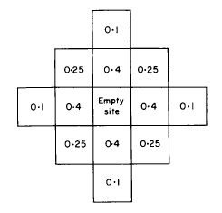Pi (i = 1, 2, 3, 4,..., 12) is a value from one of the 12 positions in figure 2 if the position is occupied by a ramet, otherwise Pi is zero. [1]

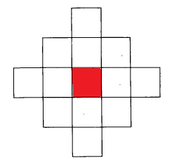

Figure 2: Probability Pi of each cell in the neighborhood [1]

Figure 1: Cell Neighborhood

Originally, the death of ramets (death rule) was going to be caused by choosing random squares of size ‘*A’*within the cell-space, where ‘*A’* is the side length in cell units, and killing all the ramets within this square but due to some limitations the death rule was switched to be caused by an overcrowded population. The simulation will start by randomly sowing 9 genets, each consisting of one ramet, and then exposed to the death rule. Subsequent iterations will then be carried out by applying the growth rule, followed by the death rule.

# Part II – Specifications

The simulator contains 3 Cell-DEVS coupled model but they are all similar with just a difference in the cell space dimensions and the initial values. The main Cell-DEVS model will be described below and is named GandR.ma. A Cell-DEVS coupled model is defined as follows:

$$GCC = < X_{list}, Y_{list}, I, X, Y, η, N, \{r, c\}, C, B, Z, select>$$

In this case, there are no external inputs or outputs therefore Xlist, Ylist and I are null.

$$Xlist = Ylist = I = \{∅\}$$

$X=Y=(0,1,2,3,4,5,6,7,8,9)$; These numbers will be used to represent ramets from different colonies

$$η=13 neighbors$$

$N=\left\{\left(-2,0\right), \left(-1,-1\right), \left(-1,0\right), \left(-1,1\right), \left(0,-2\right), \left(0,-1\right), \left(0,0\right), \left(0,1\right), \left(0,2\right), \left(1,-1\right), \left(1,0\right), \left(1,1\right), \left(2,0\right)\right\}$; Shape of the neighborhood

$r=60 , c=60$; Dimensions of the cell space are given in rows and columns

$$C = \{C_{ij} / i∈[0,59] ˄j∈[0,59]\}$$

$B =\left\{∅\right\}$; Meaning the border is wrapped

$Z :$

$P_{ij} Y_{1} → P_{i-2j} X_{1}$, $P_{ij} Y_{2} → P_{i-1j-1} X_{2}$, $P_{ij} Y_{3} → P_{i-1j} X_{3}$, $P_{ij} Y_{4} → P_{i-1j+1} X_{4}$

$P_{ij} Y_{5} → P_{ij-2} X_{5}$, $P_{ij} Y_{6} → P_{ij-1} X_{6}$, $P_{ij} Y_{7} → P_{ij} X_{7}$, $P_{ij} Y_{8} → P_{ij+1} X_{8}$

$P_{ij} Y_{9} → P_{ij+2} X_{9}$, $P_{ij} Y_{10} → P_{i+1j-1} X_{10}$, $P_{ij} Y_{11} → P_{i+1j} X_{11}$,

$P_{ij} Y_{12} → P_{i+1j+1} X_{12}$, $P_{ij} Y_{13} → P_{ij+2} X_{13}$

There is only one set of rules consisting of 14 rules in total. The first 12 rules are similar in that they calculate the probability of cell (0, 0) being colonized by a neighbor (excluding cell (0, 0)) if it was empty, each rule corresponds to one of the neighbors. The equation used to calculate the probability is shown below:

$$P_{I}^{'}=\left(\frac{P_{I}}{\sum_{i=1}^{12}{Pi}}\right)\left(1-\prod_{i=1}^{12}{\left(1-P_{i}\right)}\right) CITATION Ola89 \backslash l 1033 [1]$$

Rule 1 which calculates the probability of the neighboring cell (-2, 0) colonizing cell (0, 0) is shown as an example below:

%probability to be colonized by the neighbor (-2,0)

rule : {(-2,0)} 1000 {(0,0) = 0 and (-2,0) > 0 and random < ((0.1/( if(((-2,0)>0),0.1,0)+ if(((-1,-1)>0),0.25,0)+ if(((-1,0)>0),0.4,0)

+ if(((-1,1)>0),0.25,0)+ if(((0,-2)>0),0.1,0)+ if(((0,-1)>0),0.4,0)+ if(((0,1)>0),0.4,0)+ if(((0,2)>0),0.1,0)+ if(((1,-1)>0),0.25,0)+ if(((1,0)>0),0.4,0)+ if(((1,1)>0),0.25,0)+ if(((2,0)>0),0.1,0) )) *(1- ( if(((-2,0)>0),0.9,1) * if(((-1,-1)>0),0.75,1)* if(((-1,0)>0),0.6,1)* if(((-1,1)>0),0.75,1)* if(((0,-2)>0),0.9,1)* if(((0,-1)>0),0.6,1)

* if(((0,1)>0),0.6,1)* if(((0,2)>0),0.9,1)* if(((1,-1)>0),0.75,1)* if(((1,0)>0),0.6,1)* if(((1,1)>0),0.75,1)* if(((2,0)>0),0.9,1) ))) }

If the conditions of rule one are met then the result is that the contents of cell (0, 0) will be replaced with the contents of cell (-2, 0). Rule 13 is shown below, it has a 40% chance if killing the ramet in cell (0, 0) if there are less than 3 empty cells around it.

% 40% chance a ramet dies if overcrowded

rule : {0} 1000 {((0,0) > 0) and (falseCount < 3) and (random < 0.4)}

Rule 14 is shown below; it keeps the contents of the cell the same if all other rules were not met.

%otherwise stay the same

rule : {(0,0)} 1000 {t}

# Part III – Execution results

The ReadMe.txt file contains the information about all the files used for each test.

## Single Ramet Test

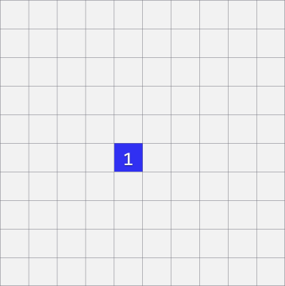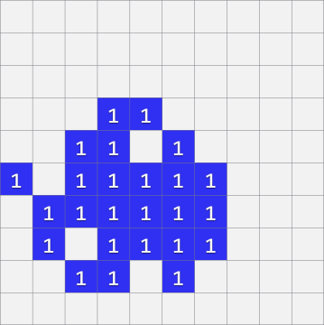The single ramet test will use only one type of ramet and will have a small cell space with the dimensions (10, 10). This test is to visualize the spread of a ramet. Figure 3 and 4 show the cell space at the start of the simulation and a few steps afterwards.

Figure 4: 4 steps after the start

Figure 3: start of the simulation

## Two Colonies Test

The two colonies test will use two types of ramets, each producing a colony. The cell space will have the dimensions (15, 15). This test is to visualize the interactions of the colonies. Figure 5 and 6 show the cell space at the start of the simulation and a few steps afterwards. The results show that black colony has moved into the middle of the blue colony and dispersed. The results also show that the blue colony has spread throughout the cell space and has the chance to take over the black colony.

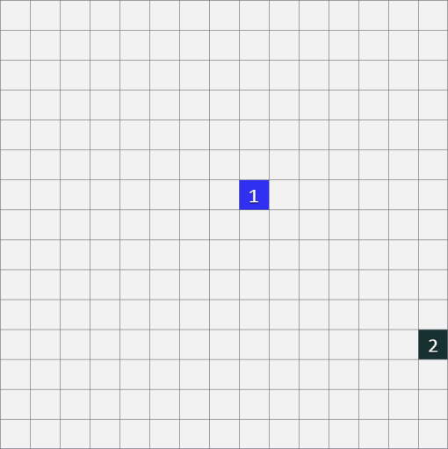 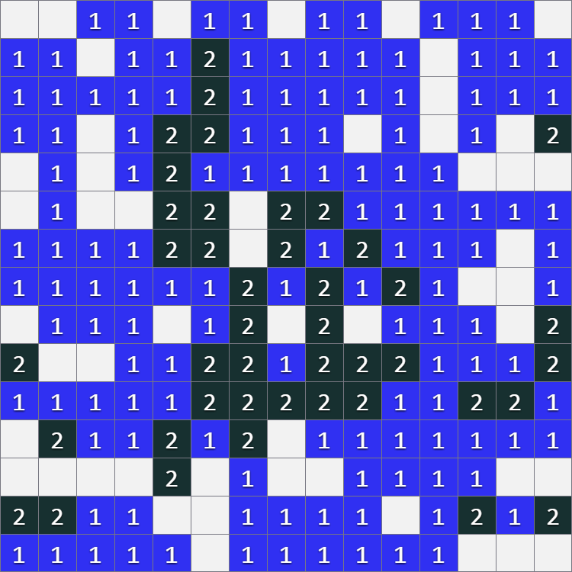

Figure 5: start of the simulation Figure 6: end of the simulation

## Main test

The main test will be carried out as mentioned in part I. 9 ramets will be placed randomly in a cell space with the dimensions (60, 60). The simulation time was 20 minutes and 10 seconds, this produces 1210 frames with the 1000 ms default delay. Please refer to the video file GandRvideo.mp4 for the results of this simulation. Two stages can be identified in this test. The first stage is the rapid growth and colonization of the whole cell space by the ramets until different colonies collide; in this simulation, this happens within the first second of the video as shown in figure 7 and figure 8.

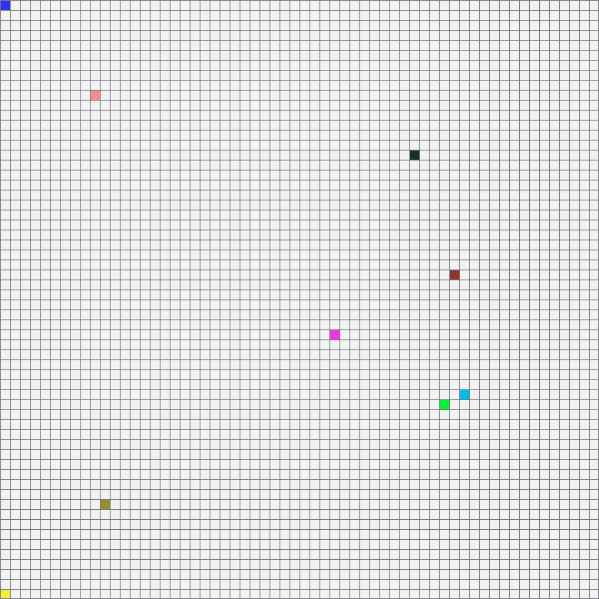 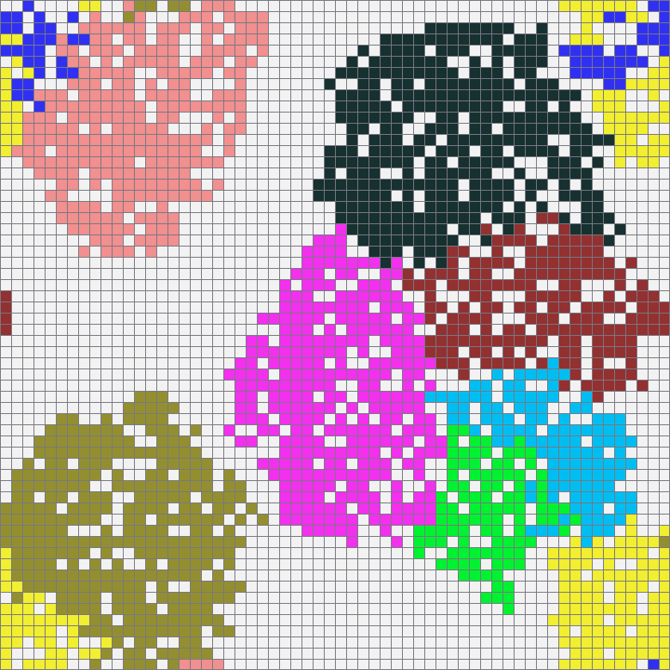The second stage is when the colonies start competing for empty cells near each of the colonies borders; colonies here may increase or decrease in size, shift places, diffuse into one another and/or die out. Figures 9, 10 and 11 show the colonies near the start, middle and the end of the simulation. Note how the colonies shift in the cell space, this can be seen clearly by comparing the brown colony from figure 9 and 10. The green colony can be seen dying out by comparing figure 10 and 11. We can deduce from this simulation that colonies that start with no competition tend to spread at a faster rate than colonies with competition. Also colonies that start by being placed close to another colony tend to be smaller and are more prone to dying out than colonies that start by being placed further apart.

Figure 7: Initial ramet placement

Figure 8: rapid growth

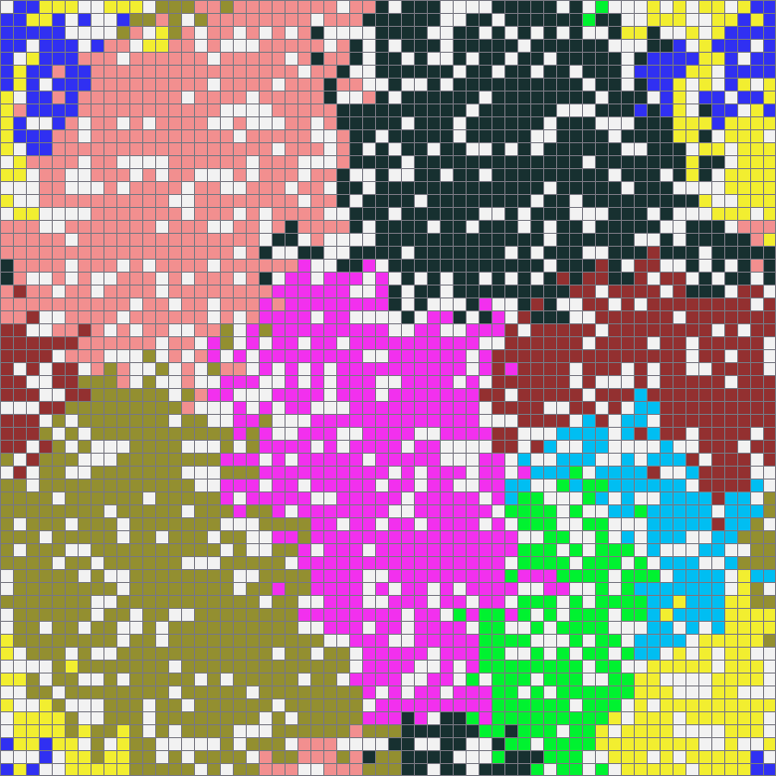

Figure 9: early time during the simulation

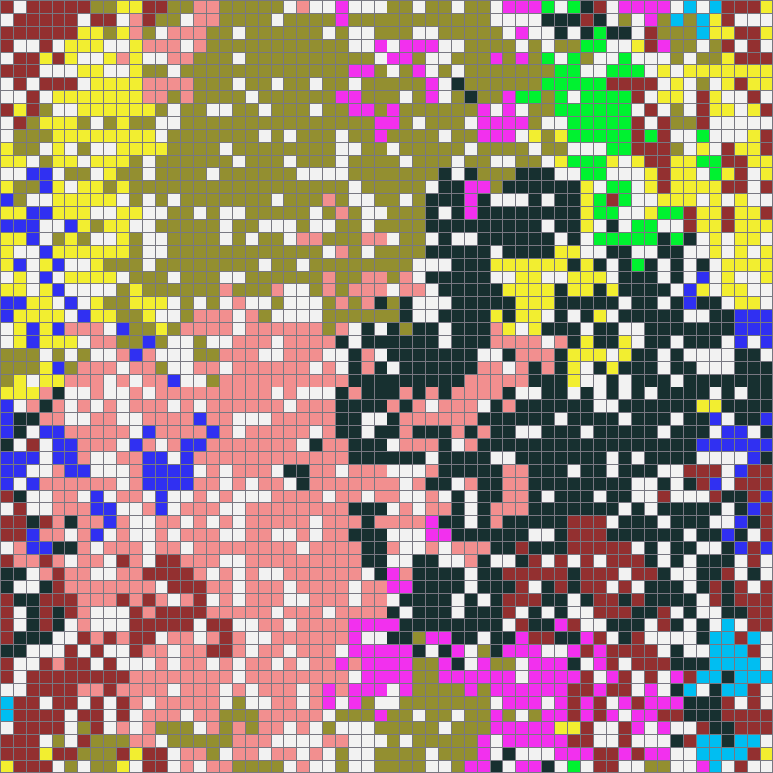

Figure 10: mid point

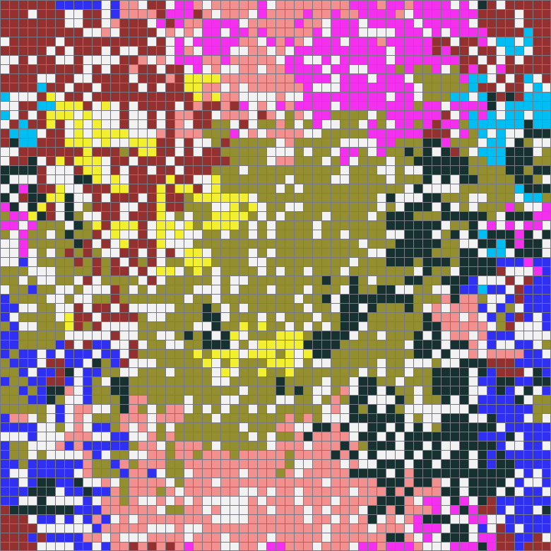

Figure 11: late time during the simulation

# References

|  |  |
| --- | --- |
| [1] | O. Inghe, "Genet and Ramet Survivorship under Different Mortality - A Cellular Automata Model," *Journal of Theoretical Biology,* no. 138, pp. 257-270, 1989. |